### ER DIAGRAM

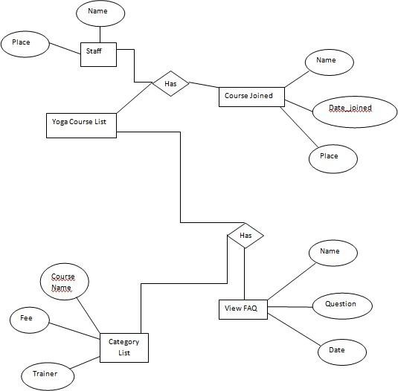

Data Flow Diagram:-

A data flow diagram (DFD) is a graphical representation of the "flow" of data through an information system. DFDs can also be used for the visualization of data processing (structured design). On a DFD, data items flow from an external data source or an internal data store to an internal data store or an external data sink, via an internal process.

A DFD provides no information about the timing of processes, or about whether processes will operate in sequence or in parallel. It is therefore quite different from a flowchart, which shows the flow of control through an algorithm, allowing a reader to determine what operations will be performed, in what order, and under what circumstances, but not what kinds of data will be input to and output from the system, nor where the data will come from and go to, nor where the data will be stored (all of which are shown in DFD).

**Level 0:**

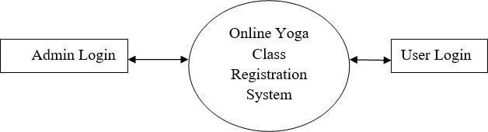

**Level 1:**

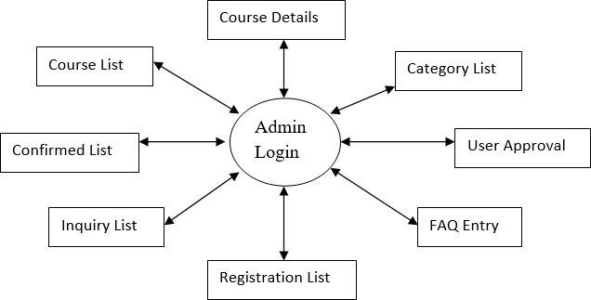

,



**Level**



**2:**

